Project title: petrol pump management system.

Author name: Yawar Ahmed(8782)

**Introduction:**

The Current System is the manual one, hence is not speedy, accurate, efficient as well as time consuming. An essential part of the system analysis, which enables the developer to understand & the system correctly. It is undertaken to obtain details of the system. To understand the physical flow of the information through the current system. Collect various information through various fact finding techniques. Identify the procedural difficulties experienced by the user. Study the bottlenecks find out the redundant work being performed in the system.

Fact Finding Techniques Employed

1. **Interviews**

Information was obtained from the employees at the organization by interviewing them at the location and time convention both.

2. **Document Searching**

An extensive study of existing document an official correspondence was done to understand the present working status of organization.

**System Design**

- PETROL PUMP MANAGEMENT SYSTEM PROJECT:

**Converting ERD to Tables**

CREATE TABLE [dbo].[users] (

[userId] INT NOT NULL,

[password] NVARCHAR (50) NULL,

PRIMARY KEY CLUSTERED ([userId] ASC)

);

insert into users

values(8782,'1234')

--------------------------------------------------

CREATE TABLE [dbo].[cus_details] (

[Id] INT NOT NULL,

[customer_name] VARCHAR (50) NULL,

[vechile_no] VARCHAR (50) NULL,

[mobile_no] VARCHAR (50) NULL,

[amount] INT NULL,

PRIMARY KEY CLUSTERED ([Id] ASC)

);

insert into cus_details

values(1,'laddan','kkk-123','0900-78601',500)

insert into cus_details

values(2,'tanzeel','aaa-777','030024567894',1000)

insert into cus_details

values(3,'ahsan','amz-654','0315-8754123',2500)

insert into cus_details

values(4,'hamza','bms-973','0346-7894563',4250)

insert into cus_details

values(5,'zaroon','kkl-252','0334-45623199',650)

---------------------------------------------------------

CREATE TABLE [dbo].[emp_details] (

[Id] INT NOT NULL,

[employee_name] VARCHAR (50) NULL,

[age] INT NULL,

[cnic_no] VARCHAR (50) NULL,

[mobile_no] VARCHAR (50) NULL,

[salary] INT NULL,

PRIMARY KEY CLUSTERED ([Id] ASC)

);

insert into emp_details

values(1,'zain',21,'42101-124859-7','0312-2547915',10000)

insert into emp_details

values(2,'yawar',20,'42101-1268739-7','0317-2843976',30000)

insert into emp_details

values(3,'bilal',24,'42101-1268739-7','0317-2843976',20000)

insert into emp_details

values(4,'tanzeel',21,'42101-5665465+7','0345-4561237',25000)

insert into emp_details

values(5,'khurram',40,'42101-1459862-4','03112645946',50000)

-------------------------------------------------------------

**Future Enhancement**:

Being a computer system, the system has good scope to be improved further.

Future Enhancements are as listed below

· Administrator can be given more rights so that he will be able to change order details.

· Type 4 driver will be used so that system will work faster.

· I will develop the system on LAN to setup the connection between other petrol pump of same company.

**Conclusion**

- PETROL PUMP MANAGEMENT SYSTEM PROJECT:

System helps to store all the data about the customer order in computer and there is no need to do paper work.

Data is going to be preserved carefully for longer period hence proper backup is required otherwise there is chance of losing entries or data.

Source Code:

Login.cs:

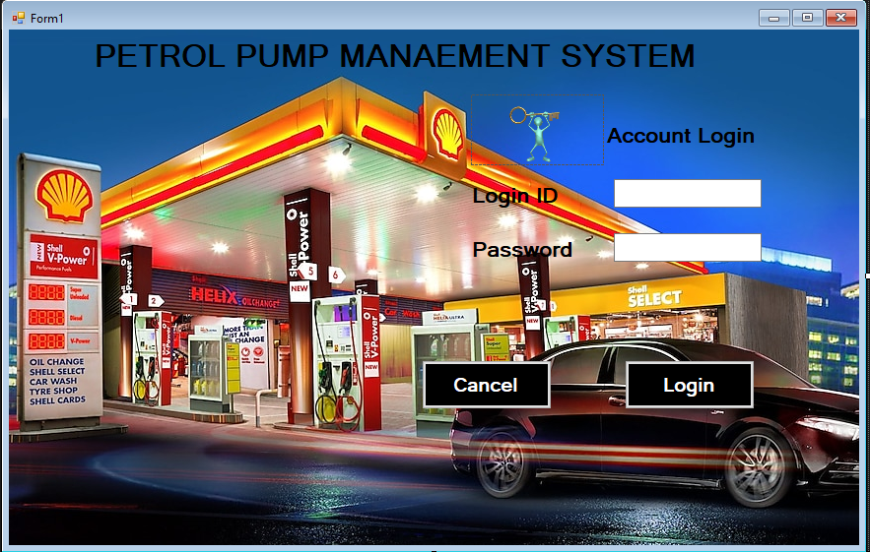

using System;

using System.Collections.Generic;

using System.ComponentModel;

using System.Data;

using System.Drawing;

using System.Linq;

using System.Text;

using System.Threading.Tasks;

using System.Windows.Forms;

using System.Data.SqlClient;

namespace WindowsFormsApplication3

{

public partial class loginForm : Form

{

public loginForm()

{

InitializeComponent();

}

private void button1_Click(object sender, EventArgs e)

{

SqlConnection con = new SqlConnection(@"Data Source=DESKTOP-RSGJ5FU\SQLEXPRESS;Initial Catalog=att;Integrated Security=True");

con.Open();

int userid = Convert.ToInt16(textBox1.Text);

SqlCommand cmd = con.CreateCommand();

cmd.CommandType = CommandType.Text;

cmd.CommandText = "SELECT COUNT(*) FROM users WHERE userid='" + userid + "' AND Password='" + textBox2.Text + "'";

cmd.ExecuteNonQuery();

SqlDataAdapter da = new SqlDataAdapter(cmd);

DataTable dt = new DataTable();

da.Fill(dt);

if (dt.Rows[0][0].ToString() == "1")

{

mainmenuForm frm4 = new mainmenuForm();

frm4.Show();

}

else

{

DialogResult result = MessageBox.Show("Invalid username or password", "Warning", MessageBoxButtons.RetryCancel);

if (result == DialogResult.Retry)

{

this.Hide();

loginForm f1 = new loginForm();

f1.Show();

}

else

{

Close();

}

}

}

private void label1_Click(object sender, EventArgs e)

{

}

private void button2_Click(object sender, EventArgs e)

{

this.Close();

}

private void pictureBox1_Click(object sender, EventArgs e)

{

}

}

}

Mainmenuform.cs:

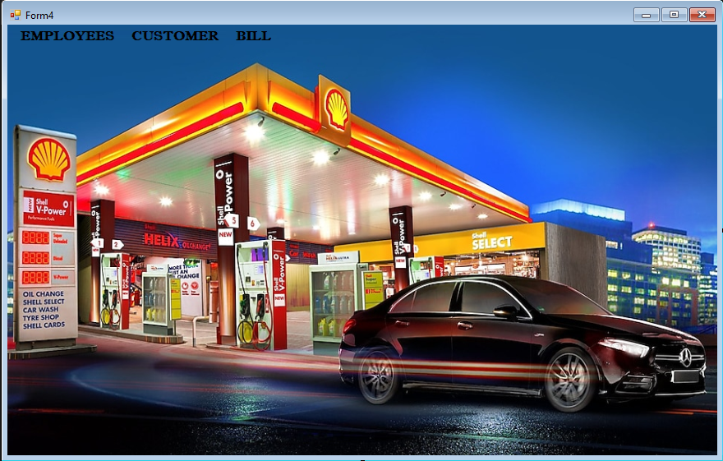

using System;

using System.Collections.Generic;

using System.ComponentModel;

using System.Data;

using System.Drawing;

using System.Linq;

using System.Text;

using System.Threading.Tasks;

using System.Windows.Forms;

namespace WindowsFormsApplication3

{

public partial class mainmenuForm : Form

{

public mainmenuForm()

{

InitializeComponent();

}

private void dETAILSToolStripMenuItem_Click(object sender, EventArgs e)

{

this.Hide();

new emp_details().Show();

}

private void gENERATEBILLToolStripMenuItem_Click(object sender, EventArgs e)

{

this.Hide();

new generate_billForm().Show();

}

private void eMPLOYEESToolStripMenuItem_Click(object sender, EventArgs e)

{

}

private void pRODUCTSToolStripMenuItem_Click(object sender, EventArgs e)

{

}

private void cUSTOMERDETAILSToolStripMenuItem_Click(object sender, EventArgs e)

{

this.Hide();

new cus_detailsForm().Show();

}

}

}

Cus_detailsform.cs

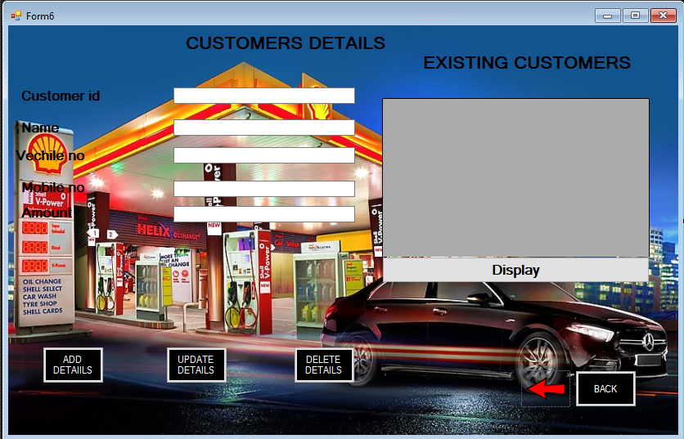

using System;

using System.Collections.Generic;

using System.ComponentModel;

using System.Data;

using System.Drawing;

using System.Linq;

using System.Text;

using System.Threading.Tasks;

using System.Windows.Forms;

using System.Data.SqlClient;

namespace WindowsFormsApplication3

{

public partial class cus_detailsForm : Form

{

public cus_detailsForm()

{

InitializeComponent();

}

private void button4_Click(object sender, EventArgs e)

{

mainmenuForm mmf = new mainmenuForm();

mmf.Show(this);

}

private void button1_Click(object sender, EventArgs e)

{

SqlConnection con = new SqlConnection(@"Data Source=DESKTOP-RSGJ5FU\SQLEXPRESS;Initial Catalog=att;Integrated Security=True");

con.Open();

int cusid = Convert.ToInt16(textBox1.Text);

string cusname = Convert.ToString(textBox2.Text);

string vech = Convert.ToString(textBox3.Text);

string mob = Convert.ToString(textBox4.Text);

int amount = Convert.ToInt32(textBox5.Text);

SqlCommand cmd = con.CreateCommand();

cmd.CommandType = CommandType.Text;

cmd.CommandText = "insert into cus_details values ('" + cusid + "','" + cusname + "','" + vech + "','" + mob + "','" + amount + "')";

cmd.ExecuteNonQuery();

MessageBox.Show("Record inserted succssfully");

textBox1.Clear();

textBox2.Clear();

textBox3.Clear();

textBox4.Clear();

textBox5.Clear();

disp_data();

}

public void disp_data()

{

SqlConnection con = new SqlConnection(@"Data Source=DESKTOP-RSGJ5FU\SQLEXPRESS;Initial Catalog=att;Integrated Security=True");

con.Open();

SqlCommand cmd = con.CreateCommand();

cmd.CommandType = CommandType.Text;

cmd.CommandText = "select * from cus_details";

cmd.ExecuteNonQuery();

DataTable dt = new DataTable();

SqlDataAdapter da = new SqlDataAdapter(cmd);

da.Fill(dt);

dataGridView1.DataSource = dt;

con.Close();

}

private void dataGridView1_CellContentClick(object sender, DataGridViewCellEventArgs e)

{

}

private void dataGridView1_CellClick(object sender, DataGridViewCellEventArgs e)

{

textBox1.Text = dataGridView1.SelectedRows[0].Cells[0].Value.ToString();

textBox2.Text = dataGridView1.SelectedRows[0].Cells[1].Value.ToString();

textBox3.Text = dataGridView1.SelectedRows[0].Cells[2].Value.ToString();

textBox4.Text = dataGridView1.SelectedRows[0].Cells[3].Value.ToString();

textBox5.Text = dataGridView1.SelectedRows[0].Cells[4].Value.ToString();

}

private void button5_Click(object sender, EventArgs e)

{

SqlConnection con = new SqlConnection(@"Data Source=DESKTOP-RSGJ5FU\SQLEXPRESS;Initial Catalog=att;Integrated Security=True");

con.Open();

SqlDataAdapter sdaa = new SqlDataAdapter("select * from cus_details", con);

DataTable dt = new DataTable();

sdaa.Fill(dt);

dataGridView1.DataSource = dt;

}

private void button2_Click(object sender, EventArgs e)

{

SqlConnection con = new SqlConnection(@"Data Source=DESKTOP-RSGJ5FU\SQLEXPRESS;Initial Catalog=att;Integrated Security=True");

con.Open();

int cusid = Convert.ToInt16(textBox1.Text);

string cusname = Convert.ToString(textBox2.Text);

string vech = Convert.ToString(textBox3.Text);

string mob = Convert.ToString(textBox4.Text);

int amount = Convert.ToInt32(textBox5.Text);

SqlCommand cmd = con.CreateCommand();

cmd.CommandType = CommandType.Text;

cmd.CommandText = "UPDATE cus_details SET customer_name = '" + cusname + "',vechile_no='" + vech+ "',mobile_no='" + mob + "',amount='" + amount + "' where id='" + cusid + "'";

cmd.ExecuteNonQuery();

MessageBox.Show("Record updated sucessfully");

textBox1.Clear();

textBox2.Clear();

textBox3.Clear();

textBox4.Clear();

textBox5.Clear();

disp_data();

}

private void button3_Click(object sender, EventArgs e)

{

SqlConnection con = new SqlConnection(@"Data Source=DESKTOP-RSGJ5FU\SQLEXPRESS;Initial Catalog=att;Integrated Security=True");

con.Open();

SqlCommand cmd = con.CreateCommand();

cmd.CommandType = CommandType.Text;

int id = Convert.ToInt16(textBox1.Text);

cmd.CommandText = "delete from cus_details where id='" + id + "'";

cmd.Parameters.AddWithValue("@id", id);

cmd.ExecuteNonQuery();

MessageBox.Show("Record has been deleted sucessfully", "deleted", MessageBoxButtons.OK, MessageBoxIcon.Information);

con.Close();

}

}

}

Emp_detailsform.cs

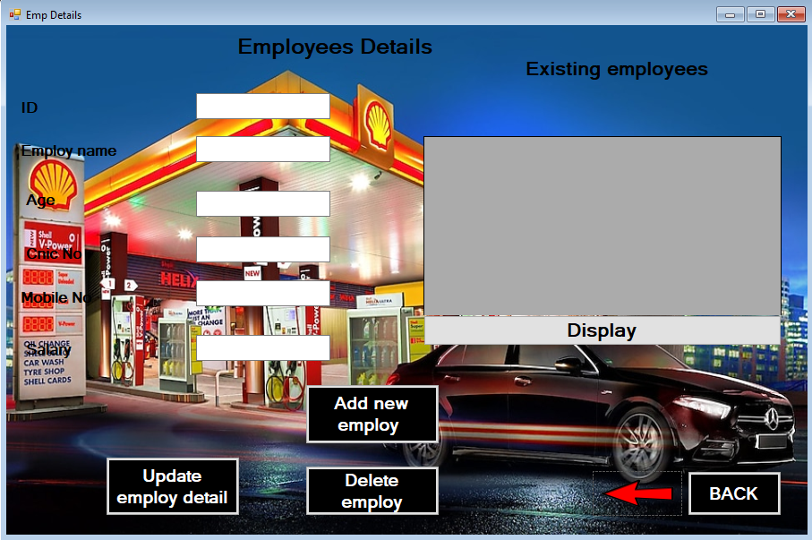

using System;

using System.Collections.Generic;

using System.ComponentModel;

using System.Data;

using System.Drawing;

using System.Linq;

using System.Text;

using System.Threading.Tasks;

using System.Windows.Forms;

using System.Data.SqlClient;

namespace WindowsFormsApplication3

{

public partial class emp_details : Form

{

public emp_details()

{

InitializeComponent();

}

private void button1_Click(object sender, EventArgs e)

{

mainmenuForm mmf = new mainmenuForm();

mmf.Show(this);

}

private void button2_Click(object sender, EventArgs e)

{

SqlConnection con = new SqlConnection(@"Data Source=DESKTOP-RSGJ5FU\SQLEXPRESS;Initial Catalog=att;Integrated Security=True");

con.Open();

int userid = Convert.ToInt16(textBox6.Text);

string name = Convert.ToString(textBox1.Text);

int age = Convert.ToInt16(textBox2.Text);

string cnic = Convert.ToString(textBox3.Text);

string mob = Convert.ToString(textBox4.Text);

int sal = Convert.ToInt32(textBox5.Text);

SqlCommand cmd = con.CreateCommand();

cmd.CommandType = CommandType.Text;

cmd.CommandText = "insert into emp_details values ('" + userid + "','" + name + "','" + age+ "','"+cnic+"','"+mob+"','"+sal+"')";

cmd.ExecuteNonQuery();

MessageBox.Show("Record inserted succssfully");

textBox1.Clear();

textBox2.Clear();

textBox3.Clear();

textBox4.Clear();

textBox5.Clear();

textBox6.Clear();

disp_data();

}

private void Form2_Load(object sender, EventArgs e)

{

disp_data();

}

private void label1_Click(object sender, EventArgs e)

{

}

private void button3_Click(object sender, EventArgs e)

{

SqlConnection con = new SqlConnection(@"Data Source=DESKTOP-RSGJ5FU\SQLEXPRESS;Initial Catalog=att;Integrated Security=True");

con.Open();

int userid = Convert.ToInt16(textBox6.Text);

string name = Convert.ToString(textBox1.Text);

int age = Convert.ToInt16(textBox2.Text);

string cnic = Convert.ToString(textBox3.Text);

string mob = Convert.ToString(textBox4.Text);

int sal = Convert.ToInt32(textBox5.Text);

SqlCommand cmd = con.CreateCommand();

cmd.CommandType = CommandType.Text;

cmd.CommandText = "UPDATE emp_details SET employee_name = '" + name + "',age='" + age + "',cnic_no='" + cnic + "',mobile_no='" + mob + "',salary='" +sal + "' where id='" + userid + "'";

cmd.ExecuteNonQuery();

MessageBox.Show("Record changed sucessfully");

textBox1.Clear();

textBox2.Clear();

disp_data();

}

private void button4_Click(object sender, EventArgs e)

{

SqlConnection con = new SqlConnection(@"Data Source=DESKTOP-RSGJ5FU\SQLEXPRESS;Initial Catalog=att;Integrated Security=True");

con.Open();

SqlCommand cmd = con.CreateCommand();

cmd.CommandType = CommandType.Text;

int id = Convert.ToInt16(textBox6.Text);

cmd.CommandText = "delete from emp_details where id='" + id + "'";

cmd.Parameters.AddWithValue("@id", id);

cmd.ExecuteNonQuery();

MessageBox.Show("Record has been deleted sucessfully", "deleted", MessageBoxButtons.OK, MessageBoxIcon.Information);

con.Close();

}

public void disp_data()

{

SqlConnection con = new SqlConnection(@"Data Source=DESKTOP-RSGJ5FU\SQLEXPRESS;Initial Catalog=att;Integrated Security=True");

con.Open();

SqlCommand cmd = con.CreateCommand();

cmd.CommandType = CommandType.Text;

cmd.CommandText = "select * from emp_details";

cmd.ExecuteNonQuery();

DataTable dt = new DataTable();

SqlDataAdapter da = new SqlDataAdapter(cmd);

da.Fill(dt);

dataGridView1.DataSource = dt;

con.Close();

}

private void dataGridView1_CellClick(object sender, DataGridViewCellEventArgs e)

{

textBox6.Text = dataGridView1.SelectedRows[0].Cells[0].Value.ToString();

textBox1.Text = dataGridView1.SelectedRows[0].Cells[1].Value.ToString();

textBox2.Text = dataGridView1.SelectedRows[0].Cells[2].Value.ToString();

textBox3.Text = dataGridView1.SelectedRows[0].Cells[3].Value.ToString();

textBox4.Text = dataGridView1.SelectedRows[0].Cells[4].Value.ToString();

textBox5.Text = dataGridView1.SelectedRows[0].Cells[5].Value.ToString();

}

private void textBox1_TextChanged(object sender, EventArgs e)

{

}

private void pictureBox1_Click(object sender, EventArgs e)

{

}

private void button5_Click(object sender, EventArgs e)

{

//dataGridView1.Show();

}

private void button5_Click_1(object sender, EventArgs e)

{

SqlConnection con = new SqlConnection(@"Data Source=DESKTOP-RSGJ5FU\SQLEXPRESS;Initial Catalog=att;Integrated Security=True");

con.Open();

SqlDataAdapter sdaa = new SqlDataAdapter("select * from emp_details", con);

DataTable dt = new DataTable();

sdaa.Fill(dt);

dataGridView1.DataSource = dt;

}

}

}

Generatebillform.cs

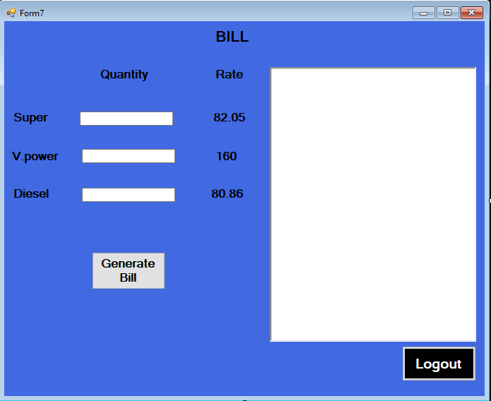

using System;

using System.Collections.Generic;

using System.ComponentModel;

using System.Data;

using System.Drawing;

using System.Linq;

using System.Text;

using System.Threading.Tasks;

using System.Windows.Forms;

namespace WindowsFormsApplication3

{

public partial class generate_billForm : Form

{

public generate_billForm()

{

InitializeComponent();

}

private void button2_Click(object sender, EventArgs e)

{

Close();

}

private void button1_Click(object sender, EventArgs e)

{

int val = 82;

int val2 = 160;

int val3 = 80;

int t,sup,v,d;

int super;

int.TryParse(textBoxs.Text, out super);

sup = super * val;

int Vpower;

int.TryParse(textBoxv.Text, out Vpower);

v = Vpower * val2;

int diesel;

int.TryParse(textBoxd.Text, out diesel);

d = diesel* val3;

t = sup + v + d;

txtresult.Clear();

txtresult.Text += "****************************************\n ";

txtresult.Text += "****************BILL******************\n ";

txtresult.Text += "****************************************\n ";

txtresult.Text += "Date :" + DateTime.Now + "\n\n";

txtresult.Text += "Super :" + sup + "\n\n";

txtresult.Text += "Vpower :" + v + "\n\n";

txtresult.Text += "Diesel :" + d + "\n\n";

txtresult.Text += "Total :" + t + "\n\n";

}

private void generate_billForm_Load(object sender, EventArgs e)

{

}

}

}